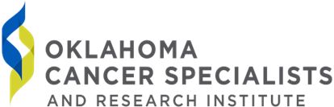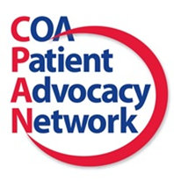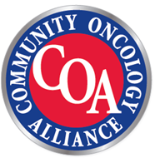

**Join the Oklahoma Cancer Specialists CPAN**

**Chapter for our next educational event**

Thursday, October 4, 2018 at 4:00pm

Oklahoma Cancer Specialists and Research Institute

12697 East 51st South, Tulsa, OK 74146

**Guest Speakers:**

* Maureen Brannon, RN, OCN, CPAN Advocacy Leader
* Maegan Stoffel, Manager Patient Services

**During this event you will learn how:**

* Prior Authorization undermines the ability of community oncology clinics to treat their patients.
* Prior authorization takes doctors’ time away from direct patient care.
* Prior authorization causes inconsistent patient treatment outcomes.

For more information or to RSVP:

Maureen.brannon@ocsri.org

For questions and/or to RSVP

**Upcoming**

**Advocacy Event**

Oklahoma Cancer Specialists & Research Institute

[www.ocsri.org](http://www.ocsri.org)

COA Patient Advocacy Network (CPAN)

[www.coaAdvocacy.org](http://www.coaAdvocacy.org)

Community Oncology Alliance

[www.communityoncology.org](http://www.communityoncology.org)